

Class | Student Number | Name

CAMBRIDGE A LEVEL PROGRAMME

AS TRIAL EXAMINATION JUN 2020
(June 2011 Intakes)

Monday 05 March 2012 9.45 am – 10.45 am

PHYSICS 9702/02

PAPER 2 AS Structured Questions 1 hour

Candidates answer on the Question Paper.
Data booklet.

READ THESE INSTRUCTIONS FIRST

Write your name, class and student number in the spaces at the top of this page.
Write in dark blue or black pen.
You may use a soft pencil for any diagrams, graphs or rough working
Do not use staples, paper clips, highlighters, glue or correction fluid.

Answer all questions.
The number of marks is given in brackets [ ] at the end of each

question or part question.

You may lose marks if you do not show your working or if you
do not use appropriate units.

For Examiner’s Use
1
2
3
4
5
6
7
8
9
Total

This document consists of 12 printed pages.

© Taylor’s College Subang Jaya 2012 [Turn over

1 (a) The units in an equation are homogeneous. Explain this statement.
…………………………………………………………………………………………
…………………………………………………………………………………….…. [1]

(b) The period T of a simple pendulum is assumed to be dependent on its mass m, length l and the acceleration g of free fall, as given by the relationship below.
each weighing scale twice just to confirm the readings. Below is a table showing the values from the two different weighing machines. The mass is given in kilograms.

T = k m^{x} l^{y}g^{z}

where k is a dimensionless quantity.

By equating the base units on both sides of the equation, deduce the values of x, y
and z.

x = ………..... y = ………… z = ……………[1]
2 (a) State Newton’s second law of motion.
………………………………………………………………………………………………………………………………………………….…………............ [2]

(b) Starting from Newton’s second law, derive the relationship F = ma, stating the
meaning of each symbol

[2]

(c) The figure below shows a system consisting of a 2.0 kg mass and a 1.0 kg
connected together by an inextensible string. The 2.0 kg mass is placed on a smooth
horizontal surface. The string passes through a light smooth pulley.
2 kg mass

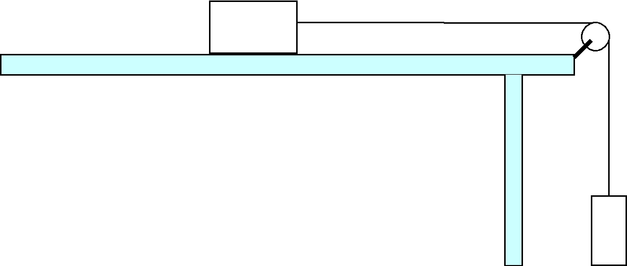

1 kg mass

(i) What is the resultant force acting on the system?

resultant force = …………....……N [1]
(ii) The whole system is released from rest. What is the acceleration of both the
masses?

acceleration = ….……...… …ms⁻² [1]

(iii) By considering the motion of the 2.0 kg mass, determine the tension in the
string.

tension = ……….…….…N [1]

3 In Fig.3.1, a bomb is dropped on an enemy target by an aeroplane flying with a
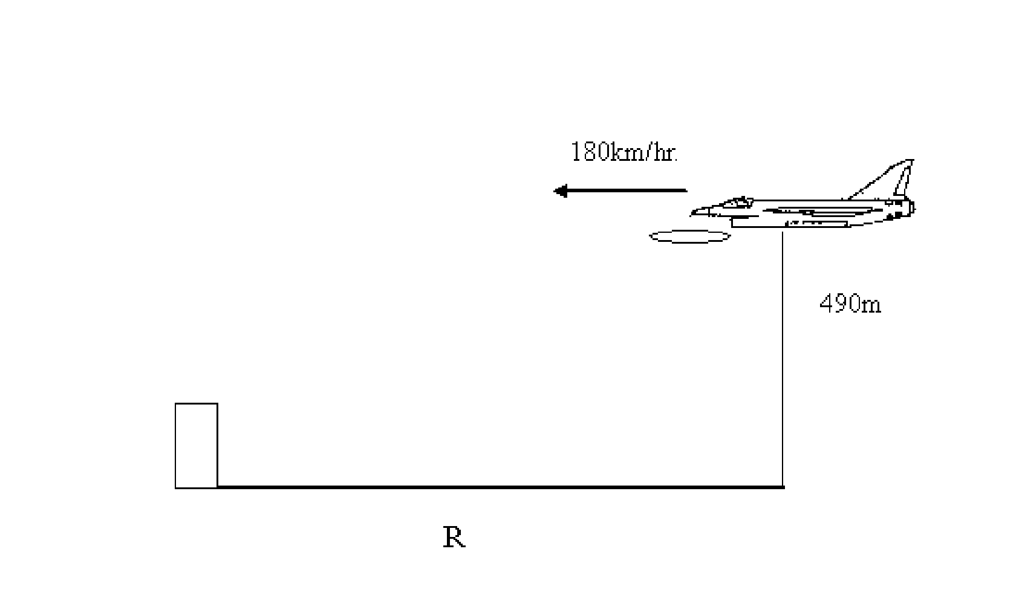
horizontal velocity of 180 km hr⁻¹ and at a height of 490 m.

Target

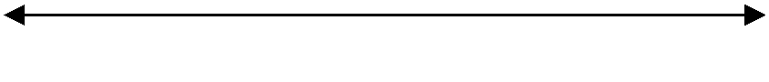

Fig. 3.1

At what distance R must the aeroplane be at the time of dropping the bomb so that it may directly hit the target? Neglect the dimensions of the target.

R = ……….……...m [3]
4 A square uniform trapdoor is shown in Fig. 2.1. It is hinged on a wall and is held
open at an angle to the horizontal by means of a rope attached as shown.

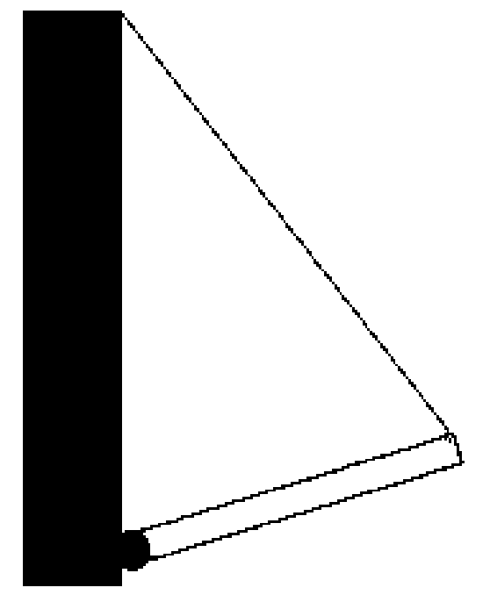

Rope

Wall

Trap door



Hinge

(a) On the diagram, mark with an arrow labeled W, the weight of the trapdoor. [1]

(b) Mark on the diagram an arrow labeled T, to represent the tension of the rope acting
on the trapdoor [1]

(c) Finally draw an arrow labeled R, to represent the force on the trapdoor due to the
hinge. [1]

5 The Young’s modulus, Y of a copper wire can be represented by the equation:

E = 4MgL

πD²e

Where M is the mass of the wire

g is the acceleration of gravity

L is the original length of the wire
D is the diameter of the wire

e is the change in length of the wire

(a) (i) What are the base S.I. units for Young’s modulus ?

Units = …………… [2]

(ii) Suggest another physical quantity which has the same units.
……………………………………………………………….……………....... [1]

(b) The value of the Young’s modulus of copper is 1.2 x 10¹¹ N m⁻² and the %
uncertainties of M is 3 %, L = 2 %, e =1 % and D = 2 %. Find the uncertainty in
the value of E and write down the answer together with its uncertainty

E =..…….…. ± ……..…. N m⁻² [3]
(c) Distinguish between elastic and plastic deformation.
……………………………………………………………………………………………………………………………………………………………………………………………………………………………………………………………………………………………………………………………………………………..……….............. [2]

(d) Explain why Young Modulus (E) is a better quantity to represent elasticity than force
constant (k).
……………………………………………………………………………………………………………………………………………………………………………………………………………………………………………………………………………………………………………………………………………………..……….............. [2]

6 (a) Explain what is meant by superposition of waves.
…………………………………………………………………………………………………………………………………………………………………………………………………………………………………………………………………………………...………[2]

(b)Distinguish between constructive and destructive interference.
…………………………………………………………………………………………………………………………………………………………………………………………………………………………………………………………………………………………………………………………………………………………………………………………………………………………………………………………………………………………………………………………………… ………………………………………………...…[4]

(c) State two conditions necessary for sources of waves to be coherent.
1 ……………………………………………………………………………………………..…
2 …………………………………………………………………………...………………[2]

(d) Why is it necessary to have two coherent sources to produce an interference pattern?
…………………………………………………………………………………………………………………………………………………………………………………………………………………………………………………………………………...………………[2]

7 (a) (i) State what is meant by the diffraction of a wave.
…………………………………………………………………………………………………………………………………………………………………………………...………[2]

- The diagram of figure 1.1 and figure 1.2 represents plane wavefronts approaching awide gap a narrow gap respectively.

Fig. 1.1 Fig. 1.2

Draw on each diagram lines, illustrating diffraction, to represent the wavefronts after passing through the gaps. [3]

(b) Parallel monochromatic light is incident normally on a diffraction grating having 3.0 x 10⁵ lines per meter. A meter rule positioned 2.00 m from the grating and parallel to its plane is shown below.
Grating
2.00 m
45.0 cm
9.0 cm
81.0 cm
Monochromatic light

The axis of the rule is normal to the lines of the grating. Bright lines are observed on the rule at the 9.0 cm, 45.0 cm and 81.0 cm marks. Calculate the wavelength of the light.

wavelength = ……...…..…….m [2]

8 (a) (i) Define electromotive force (e.m.f) and potential difference (p.d).
……………………………………………………………………………………………………………………………………………………………………………………………………………………………………………………………………………………………………………………………………………………………………………………………………………………………………………… ………………….………………….……..[2]

(ii) Explain briefly why pd will be less than emf across a cell in a close circuit.
…………………………………………………………………………………………………………………………………………………………………………………………………………………………………………………………………………………………………………………………………………………………….………………………………[3]

(b) (i) State Kirchhoff’s second law.
………………………………………………………………………………………………………………………………………………………………………………………………………………………………………………………………..……….…………………..[2]

(ii) In order to supply sufficient current to light a lamp of resistance 0.50 Ω a student uses two dry batteries, each with e.m.f. 1.5 V and internal resistance 1.0 Ω. They are connected in parallel as shown in the diagram below.

1.5 V, 1.0 Ω
1.5 V, 1.0 Ω
0.50 Ω Lamp

Calculate the power dissipated by the lamp. [3]

9 State the nature of the following radiations.
Alpha particals: ……………………………………………………………….…………………………….
……………………………………………………………………………………………..
Beta particals: …………………………………………………………………………..…………….......
………………………………………………………………………….……………........
Gamma ray: ………………………………………………………………………………………….....
……………………………………………………………………..……………………[3]

